Quiz #3 – Practice Questions

- The early stages of cleavage are characterized by:
A. formation of a hollow ball of cells
B. formation of the zona pellucida
C. increase in the size of the cells in the zygote
D. increase in the number of cells in the zygote
E. none of the above

During the implantation, the trophoblast differentiates into
A. syncytiotrophoblast
B. epiblast
C. cytotrophoblast
D. yolk sac

E. Both A and C

The first two intraembryonic germ layers (from the embryoblast) to differentiate are the
A. ectoderm and hypoblast
B. epiblast and hypoblast
C. ectoderm and endoderm
D. ectoderm and mesoderm

The bilaminar germ disc
A. consists of epiblast and mesoblast
B. is derived from the outer cells of the morula
C. forms the embryo proper
D. becomes the placenta

The primitive streak first appears at the end of the _____ week.
A. first
B. second
C. third
D. fourth
E. fifth

Cells from the primitive streak DO NOT become
A. endoderm
B. mesoderm
C. paraxial mesoderm
D. notocord

The primitive streak
A. is derived from the outer cells of the morula
B. is formed during the fourth week of development
C. becomes the mouth
D. is the site of the invagination of epiblast cells which form the mesoderm

What is the resulting form derived from the process of transverse folding? What new structures are generated? You may draw a diagram.

What tissue layer are somites derived from? ______________________What structure do they give rise to? _____________________

In mammals, the primary role of the yolk sac is to make ____________________________.

The syncytiotrophoblast penetrates the endometrium and establishes contact with the ____________________. Eventually this connection will give rise to the __________________.

The notocord becomes

the vertebrae

the somites

the nerve cord

the cartilage disks between vertebrae

the nueral tube

The chorion is the membrane that forms the placenta. It is composed of tissues from

The cytotrophoblast, embryoblast, and mesoderm

The syncytiotrophoblast, cytotrophoblast and endometrium

The endometrium, cytotrophoblast, and epiblast

The epibast, hypoblast, and yolk sac

characterize the concept of homology and explain why the structures below are homologous.

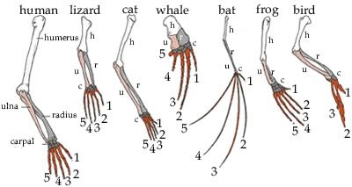

15. At what day, approximately, does the embryo start producing a heartbeat?

