Final Exam Practice - Answers

- Anatomy – The study of biological structure
Physiology – The study of biological function – the activity of cells, tissues, organs, organ systems, etc.
Cytology – The study of the structure and function of individual cells
Histology – The study of groups of cells that function cooperatively as tissue

- Anterior – In front of
Posterior – Behind
Superior – Above
Inferior – Below

- Systole is the contraction phase of the cardiac cycle, meaning it is measurement of the force of the blood (pressure) on arterial and vein walls when the heart is in contraction. This state occurs when the greatest force of pressure is exerted on the cardiovascular system, thus, the value for systole is higher than diastole when taking a blood pressure reading.
Diastole refers to the resting or relaxation phase of the cardiac cycle, meaning it is the measurement of the force of the blood on arterial and vein walls when the heart is relaxed and not in contraction. This state occurs when the least force of pressure is exerted on the CV system and it is the lower value when taking a blood pressure reading.

- Plant cells, animal cells, and eukaryotic cells

- Prokaryotic

- Cytoplasm

- C
H
K
A
E
I
J
B
D
G
F

8. This image has some things we didn’t discuss on it, but provides a nice
juxtaposition 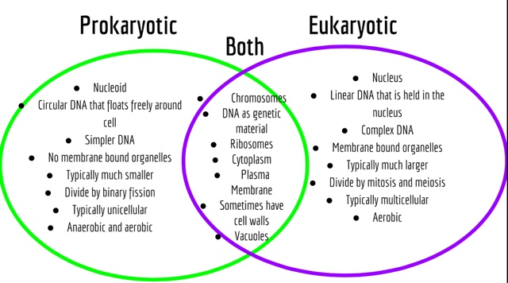

- Red Blood Cells – Have no nucleus to allow for maximum hemoglobin
content, specialized to absorb oxygen from the lungs and distribute it to all areas of the body.

White blood Cells – Specialized cells that identify, engulf and/or remove
foreign invaders from the blood stream.

Platelets – Are cell shard/fragments specialized for aiding in blood clot
formation.

Cardiac Cells – Have intercalated disks and form long fibers, giving them
structural stability and the ability to transmit electrical impulses quickly.

10.
a. 10
b. bacterium at 3 um
c. 1,000,000 to 1,000,000,000 … so canceling zeros gives 1 : 1,000
d. 1 nanometer

11. Passive diffusion is the movement of a substance, liquid, dissolved, or gaseous, from an area of higher concentration to lower concentration, the movement along a concentration gradient. In nature, without any energy inputs, a system will dissolved particle or gas will move randomly into areas of low concentration from those areas of high concentration, eventually producing an equal distribution of the substance. In the human body, areas of high or low concentration are maintained in order to insure the proper one-way flow of a substance. For instance, oxygen moves along its gradient from a high concentration in the blood cells, to areas of low concentration in the tissues of the body, as permitted by the semi-permeable membranes of the capillaries.

12. Osmosis is the movement of water from areas of higher concentration to lower concentration across a semi-permeable membrane. If the concentration of solutes inside a cell (cytoplasm) is greater than outside a cell (interstitial fluid), water will move into the cell in an attempt to balance the concentrations and vice versa if the concentration gradient is reversed.

16 (opps…) . We didn’t cover this topic, so don’t worry about it. Extra Credit perhaps?

17. This will likely be extra credit

18. Cells have different appearances and ratios of organelles relative to their functions. A liver cell, for instance, will have much of its interior devoted to smooth ER for the breakdown and removal of toxins, while a red blood cell is round and smooth for gliding easefully through the blood vessels of the CV system and is packed full of hemoglobin for the transportation of oxygen.

20 (opps again). You got this one, there are myriad examples!

