Biology I – Final Exam Practice NAME____________________________

- Describe the focus of each discipline of Biological study:

Anatomy

Physiology

Cytology

Histology

- Define the following anatomical terms

Anterior

Posterior

Superior

Inferior

- What do the terms Systole and Diastole mean? Describe their relationship to the phenomenon
of blood pressure.

- Which type of cell has membrane bound organelles? (Circle all that apply)
a. Prokaryotic Cells
b. Plant Cells
c. Animal Cells
d. Bacteria Cells
e. Eukaryotic Cells

- Which type of cells appeared first on earth?
a. Prokaryotic Cells
b. Eukaryotic Cells

- What is the fluid medium found within all cells?

- Match the following terms with the best possible description.

- Golgi Apparatus _____help propel the cell or move fluid and particles
- Rough E.R. _____The site of respiration, generates ATP
- Flagella/cilia _____Gooey splotch that synthesizes ribosomes
- Cytoskeleton _____Modifies, packages and ships cellular products
- Smooth E. R. _____Synthesizes lipids; detox of drugs and poisons
- Nucleus _____Regulates what gets in and out of the cell
- Lysosome _____Separates nucleus from the cytoplasm; contains pores
h. Mitochondria _____Synthesizes specialized proteins; is covered in ribosomes
I. Plasma Membrane _____Gives structure to the cell, transport system
j. Nuclear Membrane _____Digests old cellular compounds and cleans up the cell.
k. Nucleolus _____Contains the DNA
8. Compare and contrast Prokaryotic with Eukaryotic cells. What do they have in common? What are the main distinctions between them? Use the diagrams to highlight your answers.
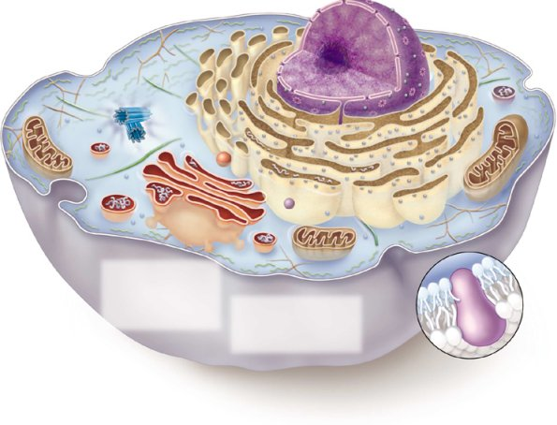

9. What are the functions/roles of these specialized cells and cell products within the human body?

Red Blood Cells

White Blood Cells

Platelets

Cardiac Cells

10. Cell Size and Scale

- If there are 100 centimeters in a meter and 1000 millimeters in a meter, how many millimeters are in a centimeter?

- Which is larger, a ribosome at 30 nanometers or a bacterium at 3 micrometers?

- What is the ratio of one micrometer to one nanometer?

- Which is smaller, something with a length of 0.1 micrometers or something with a length of 1 nanometer?

11. Explain how passive diffusion works. Give an example of the use of passive diffusion in a body system.

12. What is osmosis? How does the concentration of solutes in the interstitial fluid and cytoplasm influence the flow/diffusion of water into and out of the cell?

16. Explain how active diffusion/transport works using the diagram series below. What is required in order for this to occur?

17. Site and explain two types of polarities in the human body.

18. Why do cells look different and have different ratios/mixes of organelles? Give and example of a cell type and explain how its form is an expression of its function.

20. A major theme for this block has been that form follows function. Explain what this means and provide examples at the organ and tissue levels or organization.

